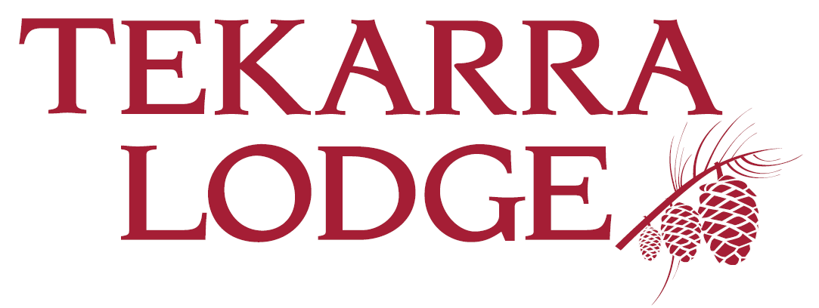
Your company, your values, your career!

HOUSEPERSON / LAUNDRY ATTENDANT

TEKARRA LODGE, JASPER, ALBERTA
Our culture is rooted in our values and leadership accountability; and as part of that culture we believe in the growth and development of our Ambassadors. Join us and be a part of an exciting place to work. The Facility Attendant will attend to general hotel appearance, guest requests and provide superior customer service to guests while completing tasks. To foster and maintain a good Occupational Health & Safety work record for the hotel.

Other responsibilities will be to conduct/perform general facility repairs within the hotel as required. Seasonally related duties are also part of this role.

Duties and Responsibilities:
- Handles assigned duties, such as cleaning all housekeeping areas and public areas of the property, taking out garbage, reporting any deficiencies to the Housekeeping or Maintenance Manager so appropriate work orders can be filed
- Performs moderately complex tasks in area of specialty, such as general repair and care of the property, reporting all health, safety, and security problems, and ensuring all tools are kept in good working order and stored properly
- Washes and dries Hotel linens according to Tekarra’s efficiency and cleanliness standards ensuring machines operate at maximum efficiency
- Keeps all machines in operation, reporting any deficiencies
- Maintains the cabins by assisting with stripping cabins, chopping and replenishing wood, changing public garbage and recycling bins
- Assists guests as required, including baggage handling
- Acts as an Ambassador for Coast, including greeting guests and handling basic inquiries
- Demonstrates a customer service attitude with internal/external contacts
- Responds to facility related emergency calls
- Other duties as assigned

Qualifications & Skill Requirements:
- Successful completion of high school education preferred, but combination of experience and education will be considered
- Self motivated team player with solid organizational and interpersonal skills required
- Demonstrated ability to work in a fast paced, multi-tasking team environment required
- Demonstrated superior customer service philosophy
- Personal alignment with Coast’s 5 core values and corporate culture required
- Good communication skills in the English language required
- Must be bondable and have a clear police clearance, background check is required upon hire

Additional information:
- Position begins early May 2023 and run until early October 2023
- Staff Accommodations available
- Year End Bonus
- All positions will receive required training to fulfill duties & responsibilities

Coast Hotels & Resorts offers a variety of benefits, including competitive wages & benefits, employee discounts, training & development, career advancement opportunities and more!

Please apply online at www.coasthotels.com/careers

