TWIGS LOUNGE

@THE SIMSBURY INN

HAPPY HOUR MENU

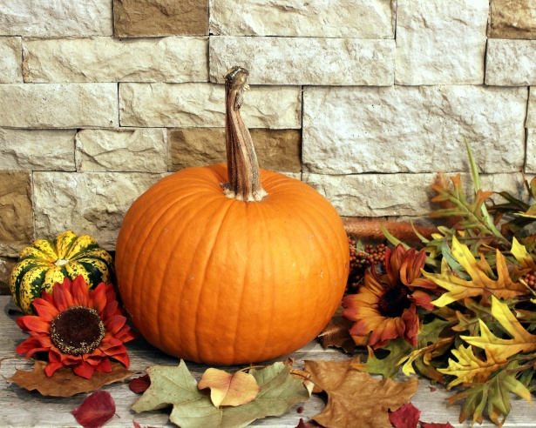

Monday - Thursday 4:00pm-6:00pm

~~~ FROM THE BAR ~~~

House Wines $4.00ea Draft & Bottled Beers $4.00ea

~~~ FROM THE KITCHEN ~~~

SHRIMP COCKTAIL
Poached Jumbo Shrimp with a cracked peppercorn
cocktail sauce & shallot lemon caper aioli GF
$2.00 per shrimp

Chicken Lemongrass Dumplings
Served with ponzu dipping sauce
$7
Philly Cheesesteak Spring Rolls
Served with jalapeno cheese sauce
$7

Cajun Fried Pickles
Served with malt vinegar aioli
$6
Fried Mushrooms
& Cheesy Broccoli
Served with horseradish
ranch dipping sauce
$6

Waffle Sweet Potato Fries
Served with maple mustard & chipotle aioli
$6

Please inform your server if you have a food allergy ~

*This menu item contains raw or undercooked ingredients

** “Thoroughly cooking meats, poultry, seafood, shellfish or eggs reduces the risk of food borne illness”

Gluten Free breads available upon request GF = Gluten Free Items 9-7-2023

