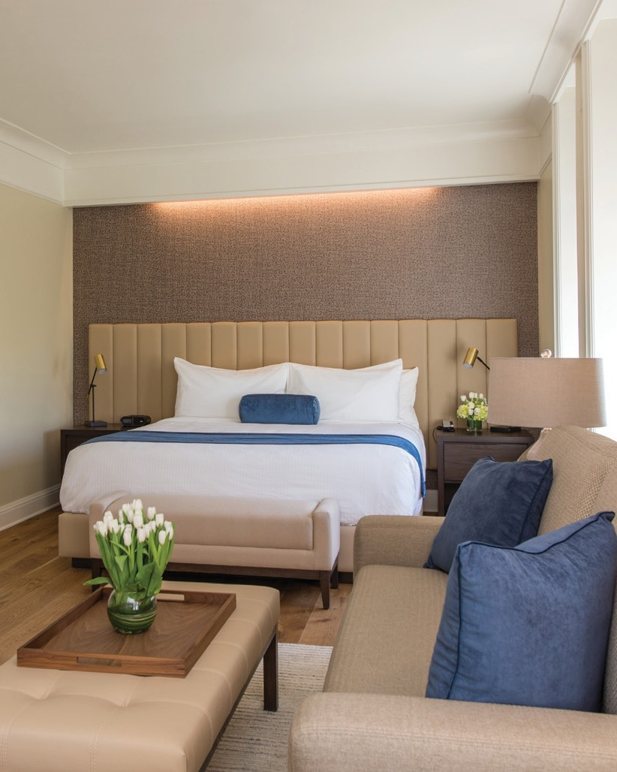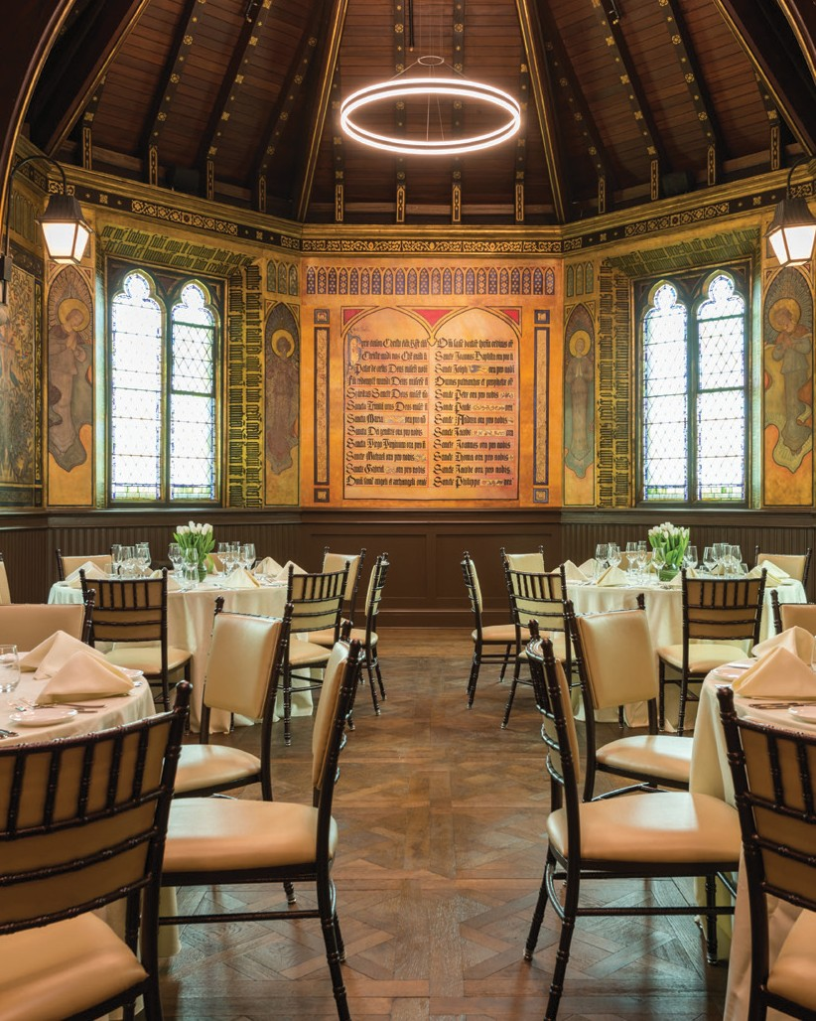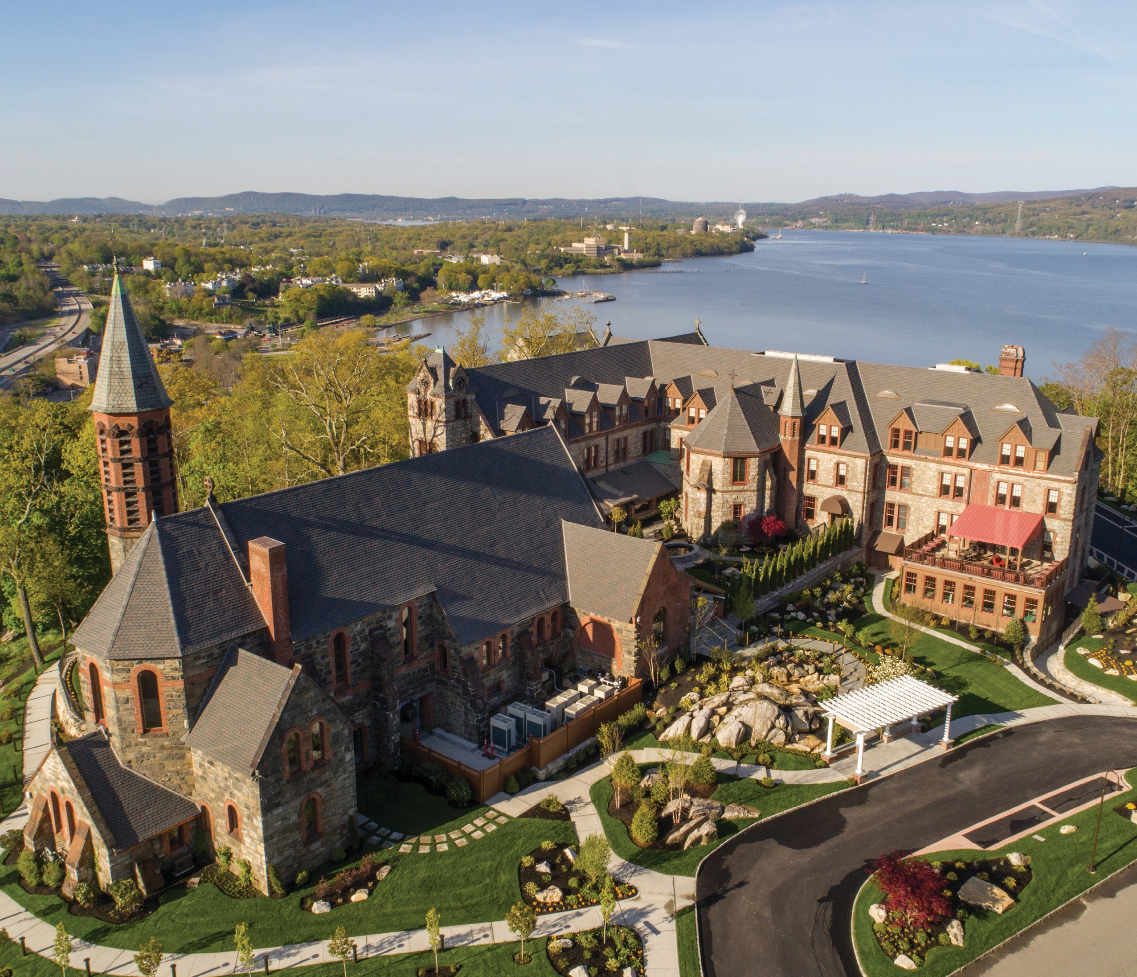
The Suite at The Abbey Inn
The Cornerstone Room

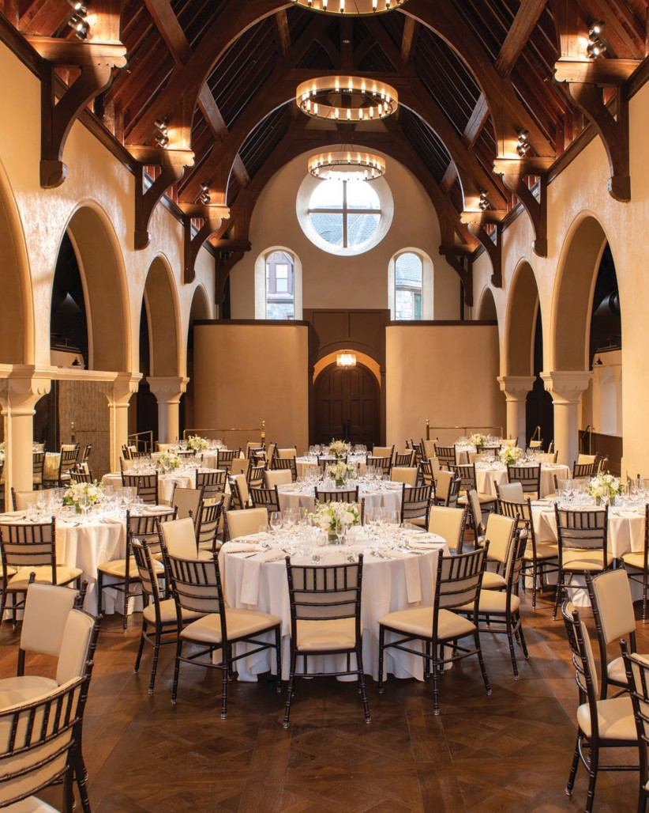
The Highlands Ballroom

WELCOME TO THE ABBEY INN & SPA
Located in Northern Westchester overlooking the Hudson River, The Abbey Inn & Spa is a luxurious
42-room boutique hotel with a full-service spa and a 116-seat restaurant, Apropos located in a restored convent and chapel atop Fort Hill in Peekskill, New York. The Abbey Inn & Spa is just one hour from
Grand Central Terminal.
As the Lower Hudson Valley’s newest and most unique catering venue, The Abbey Inn & Spa offers a diverse selection of spectacular spaces for your next milestone event, from intimate family birthday celebrations, to corporate retreats, to gala fundraisers, to enchanted weddings to remember.
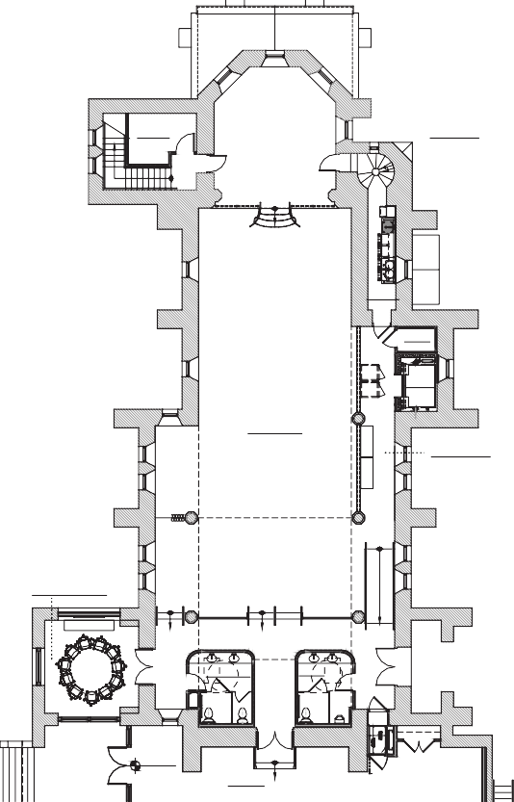Afterwards, your guests can retreat to the Abbey Inn’s beautifully appointed guest rooms and suites.
STOR.
102
EVENT#1
SERV.
103
CLO.
104A

ELEV
105
THE HIGHLANDS BALLROOM
100
66'X25.5'
2.183 SQ.FT
CORRIDOR
104
THE EXECUTIVE BOARDROOM
108
WOMEN MEN
106 107
EL. +279.8'
ENTRY
109
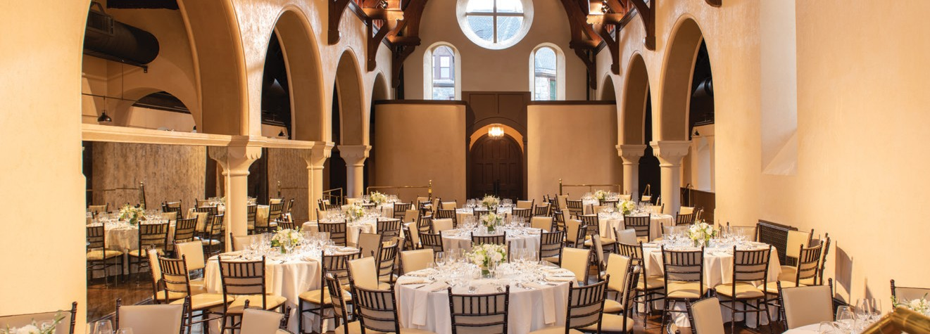
TH E HIGHLANDS BALLROOM 2,183 SQ FT
The Highlands Ballroom, located in the former church, is The Abbey Inn’s premier event space offering an undeniable “wow factor.” At over 2,000 square feet with cathedral ceilings, this soaring space can be customized for a wide range of gatherings from a spectacular wedding to business
conferences with full A/V capabilities.
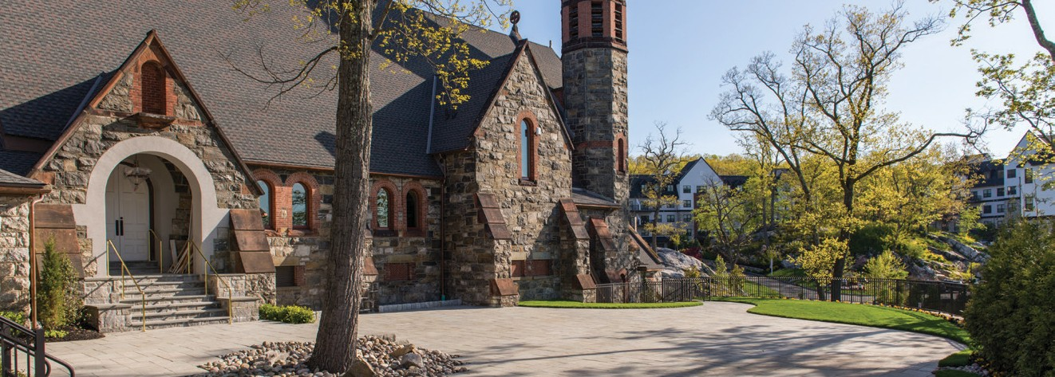
TH E GRAND TERRACE 2,000 SQ FT
Enjoy a beautiful seasonal event out on the Grand Terrace as a separate function or in conjunction with the adjacent Highlands Ballroom.
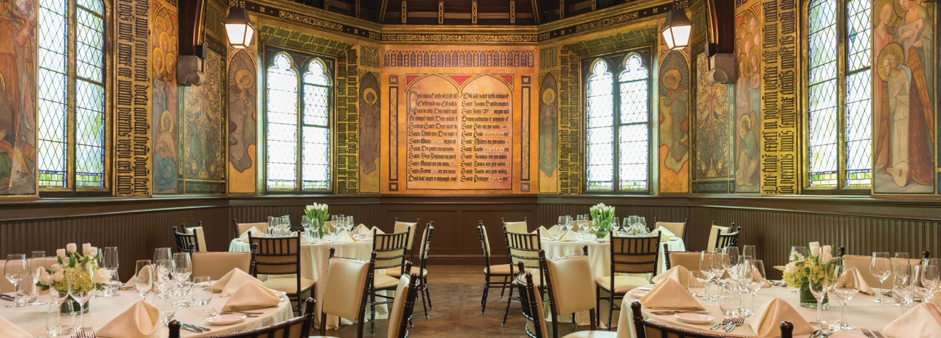
TH E CORNERSTONE ROOM 742 SQ FT
The Cornerstone Room located in the hotel building within the former convent chapel, is the perfect venue for a smaller event or a more
intimate wedding. This beautiful 742 square-foot room, adorned with historic hand-painted ecclesiastical wall coverings and stained-glass windows creates a one-of-a-kind memorable space.

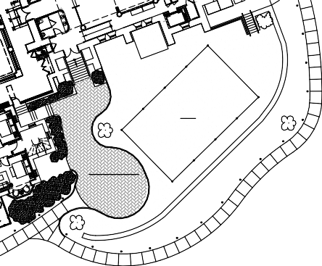THE GRAND TERRACE
TENT
GRAND TERRACE

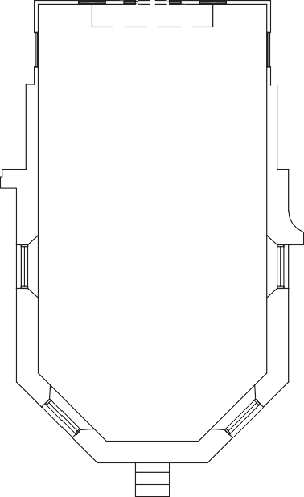

THE CORNERSTONE RM
218
20'X38.5''
742 SQ.FT
THE CORNERSTONE ROOM

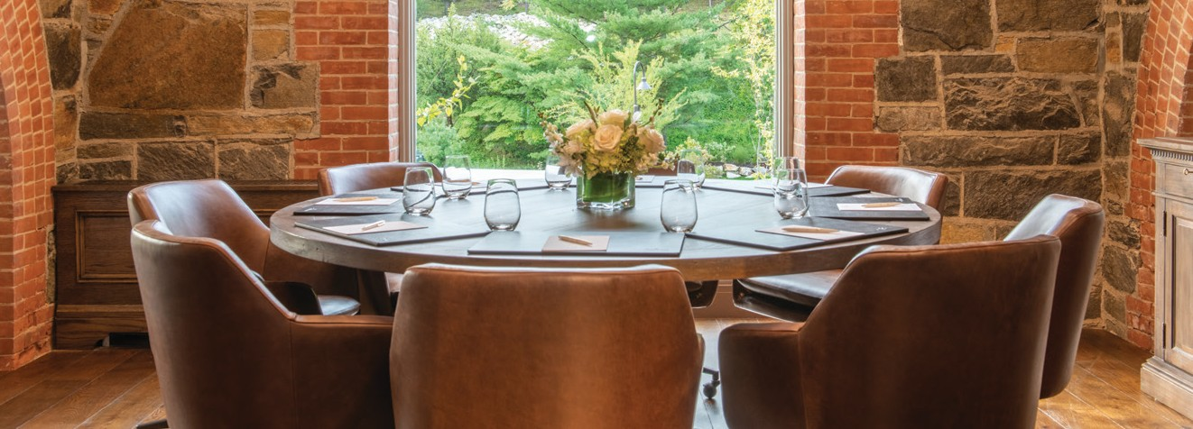
TH E EXECUTIV E BOARDROOM 241 SQ FT
Adjacent to The Highlands Ballroom the former Convent Reading Room is equipped with full A/V connections that can be used for an executive suite retreat, a breakout room or hospitality space for a wedding.
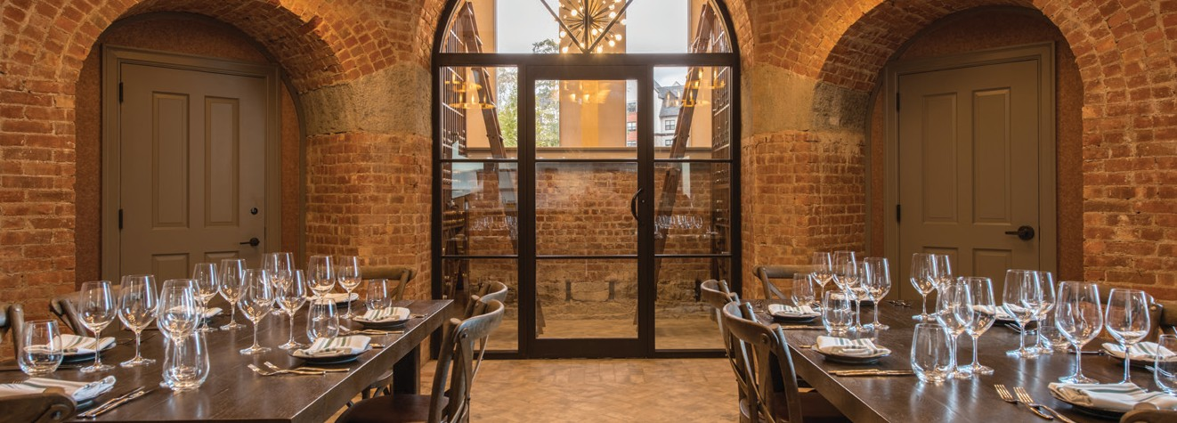
CELLAR TASTIN G ROOM 318 SQ FT
Descend beneath The Highlands Ballroom to a secluded retreat in our
wine cellar. The Cellar Tasting Room is the perfect location for a unique, private dining experience.

THE HIGHLANDS BALLROOM & THE EXECUTIVE BOARDROOM

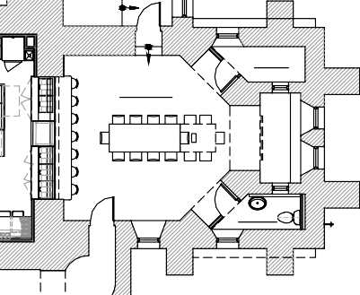
STOR.
B12
WINE TASTING
B10
PWDR.
B11
CELLAR TASTING ROOM
TH E HUDSON RIVE R ROOM 576 SQ FT
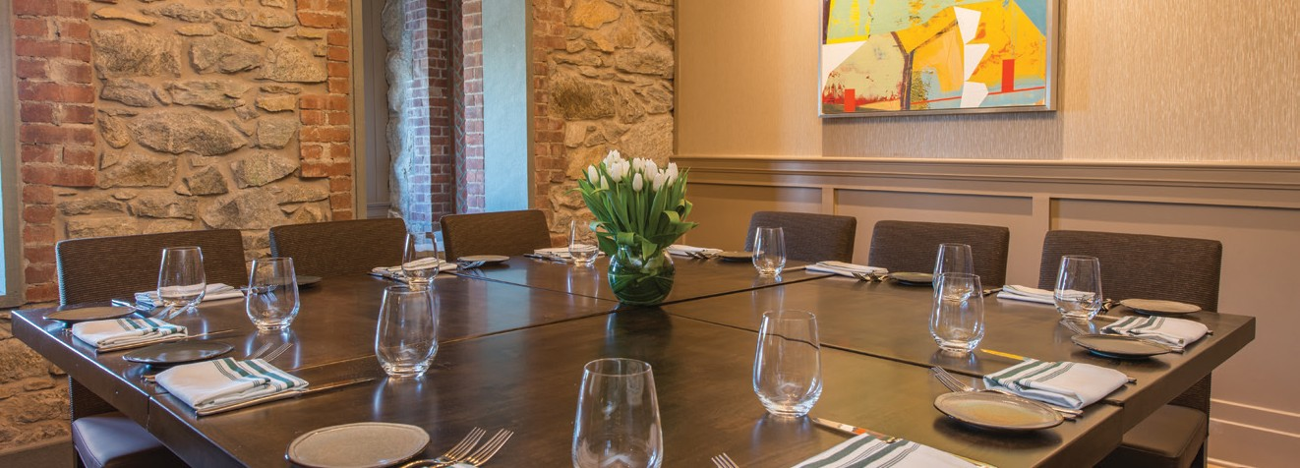
The Hudson River Room, one of Apropos Restaurant’s dining rooms within the inn, can be reserved for private parties and events. The
perfect place for a wedding rehearsal dinner, a business conference,
welcome reception, or morning after breakfast. This magnificent room offers dramatic sunset views over the Hudson River and the Highlands.
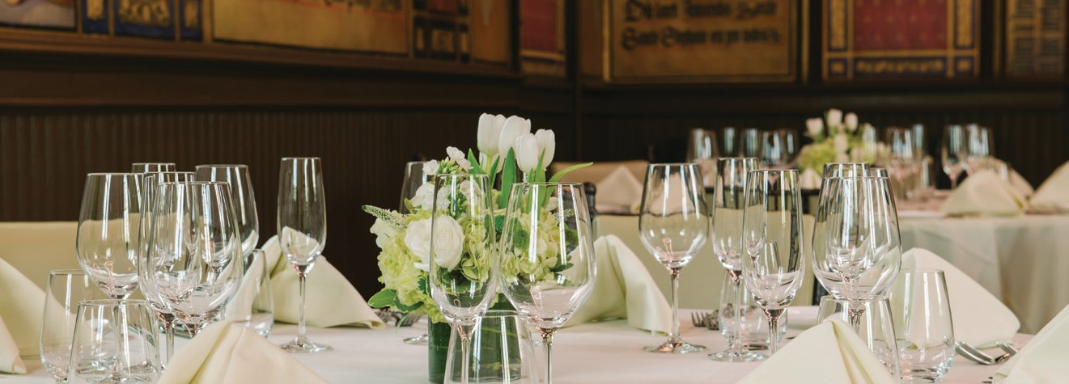
PRIVAT E DININ G ROOM 229 SQ FT
The Private Dining Room at Apropos Restaurant is ideal for a family celebration, holiday dinner or important business lunch or dinner.

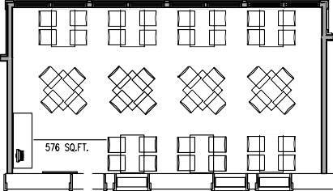THE HUDSON RIVER ROOM

THE HUDSON RIVER ROOM

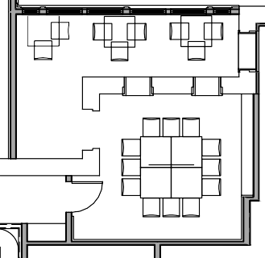
P.D.R. DECK
PRIVATE DINING

PRIVATE DINING ROOM

THE ABBEY INN MEETING SPACES

ROOM | SQ FT  LxW | CEILING HEIGHT | THEATRE | CLASS ROOM | U-SHAPE | CONF | BANQUET | RECEPTION
Highlands Ballroom | 2,183 SQ FT,  89' x 25' | 21' to 36' | 134 | 80 | 58 | 68 | 150 | 220
Cornerstone Room | 742 SQ FT,  20' x 38.5' | 12' - 22' | 100 | 30 | 24 | 26 | 40 | 64
Executive Boardroom | 241 SQ FT,  15'6" x 15'2" | 15' | N/A | N/A | N/A | 8 | 8 | N/A
Private Dining Room | 229 SQ FT,  17'6" x 14'5" | 10' | N/A | N/A | 10 | 16 | 20 | 20
Cellar Tasting Room | 318 SQ FT,  18'9" x 18'8" | 12' | N/A | N/A | N/A | N/A | 16 | 20
Hudson River Room | 576 SQ FT,  32'9" x 17'8" | 10' | N/A | N/A | N/A | N/A | 44 | 60
Grand Terrace | 2,000 SQ FT,  40' x 50' | 22' | N/A | N/A | N/A | N/A | 120 | 200

ACTIVITIES
THE ABBEY INN SPA: 2,500 SQ FT | LEISURE ACTIVITIES:  ENTERTAINMENT  Paramount Theater Trinity Cruises  Hudson Valley Center for Contemporary Art Peekskill Farmers Market  (Every Saturday, Spring to Fall 8am – 2pm) Hudson Valley Shakespeare Festival,  Cold Spring  GOLF  The Garrison Golf Club, 2015 US9, Garrison, NY  Mohansic Golf Course, 1500 Baldwin Rd, Yorktown Heights, NY  HIKING  Fort Hill Park Hiking Trail, Peekskill, NY Breakneck Ridge, Cold Spring, NY | KAYAK & CANOE RENTALS AND TOURS  Hudson River Expeditions, Peekskill, NY  OUTDOORS  Anthony’s Nose  (Appalachian Trail & Hiking)  Bear Mountain State Park  (Picnicking, Fishing, Swimming & Trails)  Blue Mountain Reserve  (Mountain Biking & Hiking) Charles Point  Hudson River Expeditions Pedal Peekskill  Riverfront Green Park
Spa Lounge
3 Individual Treatment Rooms
1 Couple Treatment Room
Men’s & Women’s Lockers
Retail Shop
ADDRESS: PHONE: EMAIL: WEBSITE:

900 FORT HILL ROAD PEEKSKILL, NY 10566
DIRECT: FAX:
914.736.1200
914.739.3705
info@theabbe yinn.com theabbe yinn.com

TOLL FREE: 833.242.9888

