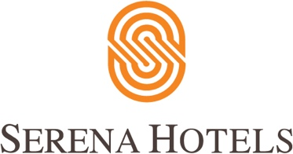

Corporate
14th March 2021
Islamabad

Serena Hotels and Margalla Greens Host High-Profile Golf Tournament

Serena Hotels co-hosted an Invitational Golf Tournament with the cooperation of the administration of the Margalla Greens Golf Club (MGGC) at the Naval Complex in E-8 on Saturday morning.

It was a colorful event and featured the participation of a large number of senior diplomats, corporate heads and high-ranking officials from the Pakistan Armed Forces alongwith their spouses on a beautiful spring day.

Serena Hotels regularly organize and sponsor sporting events under the banner of Sports Diplomacy to provide a platform for sports lovers to network and build positive relationships while sharing the joy of sports.

CEO Serena Hotels South and Central Asia Mr. Aziz Boolani said that it was the endeavor of Serena Hotels to allow people to continue enjoying healthy activities whilst fully following the Covid-19 SOPs for their safety. He also thanked the MGGC and the participants for their participation and excellent turnout, especially the enthusiastic participation of a large number of female golfers.

The prizes were distributed amongst the winners by the Ambassadors and corporate heads and included the following winners in various categories:
H.E. Dato Mahmud Saidin (1st Net) and Sen. Aizaz Ahmad Chaudhary (1st Gross) in Diplomatic Category, Mr. Taimur Abbasi (1st Net) and Mr. Imran Janjua (1st Gross) in Corporate Category, R. Adm. Imran Ahmed (1st Net) and Capt. Atif Sultan (1st Gross) in Armed Forces Category, Mrs. AM Amir Masood (1st Net) and Ms. Ami Qin (1st Gross) in Ladies Category. The subsidiary prizes included Col. Faisal Javed and Mrs. Farnaz Bajwa (Closest to Pin), Brig. Irfan Khan and Mrs. Tehmina Rashid (Longest Drive).

