For Immediate Release
Hotel Okura Manila Launches The Kisetsu Weekend Buffet
Manila, Philippines – We are delighted to announce the launch of Yawaragi Restaurant’s Kisetsu Weekend Buffet, available from Saturdays to Sundays for lunch (12 noon to 3 p.m.) and Fridays to Sunday for dinner (6 p.m. to 10 p.m.).

Kisetsu or “seasons” in Japanese, reflects the culinary philosophy of using ingredients at their prime flavor. The weekend buffet – with Sunday Lunch as the main highlight – showcases an array of Japanese specialties and international gourmet dishes from both Executive Chef Gavin Russell and Robatayaki Chef Ryuji Tsuchida.

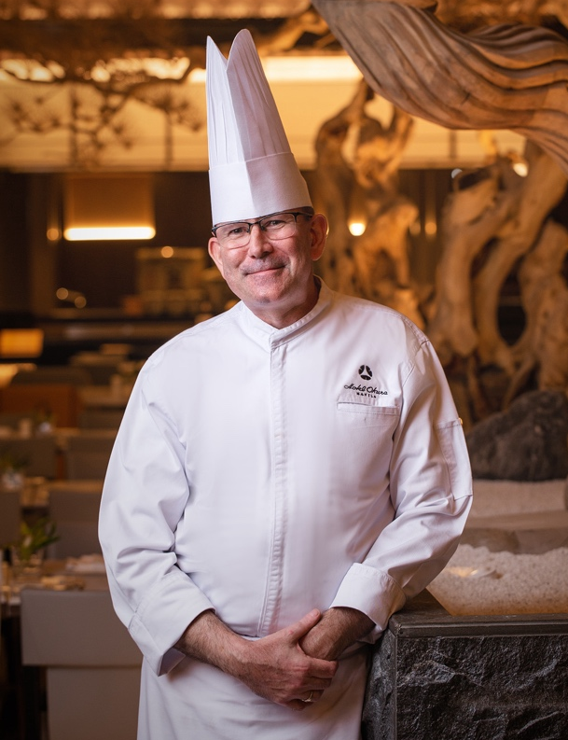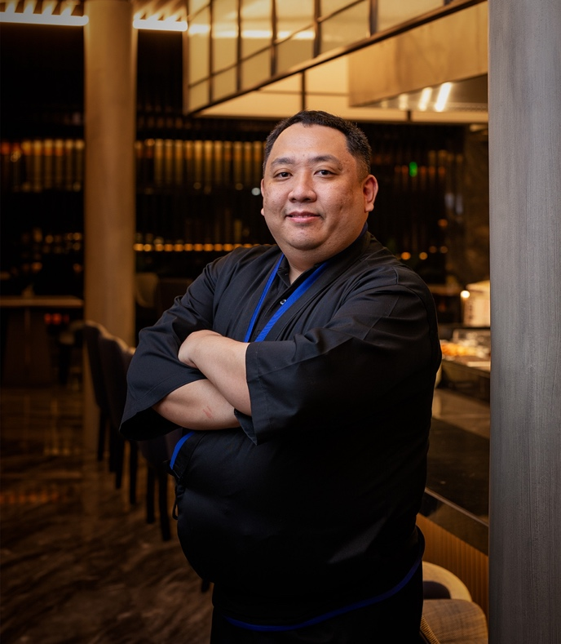
Executive Chef Gavin Russell and Robatayaki Chef Ryuji Tsuchida

The Sunday Lunch Buffet features Japanese favorites such as the prawn and vegetable tempura, maki rolls, sashimi, Japanese curry, yose nabe (hot pot), tamago yaki with stewed hijiki seaweed, grilled black cod in Saikyo miso, and udon noodles in shiitake sauce. The premium Sunday specials include tender roast sirloin of Australian beef, Alaskan king crabs, and lobsters; a roving bar cart highlights a selection of our signature cocktails along with free-flow champagnes, wines, and beers. At the robatayaki counter, chefs can grill various seafood and skewered meat a la minute for you.

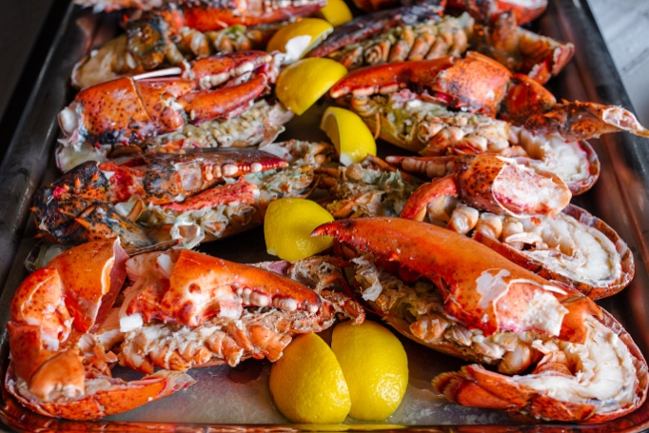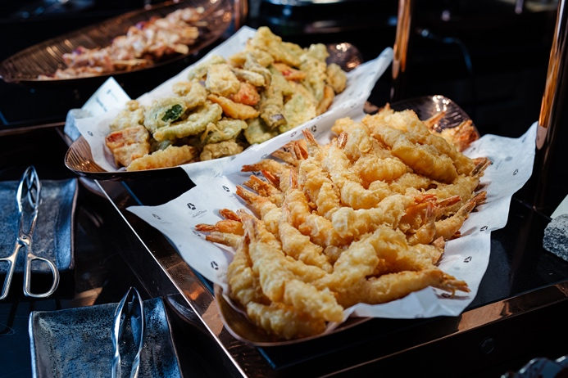
Lobsters, vegetable and prawn tempura
*Some menu items may change slightly without prior notice due to ingredient availability and quality

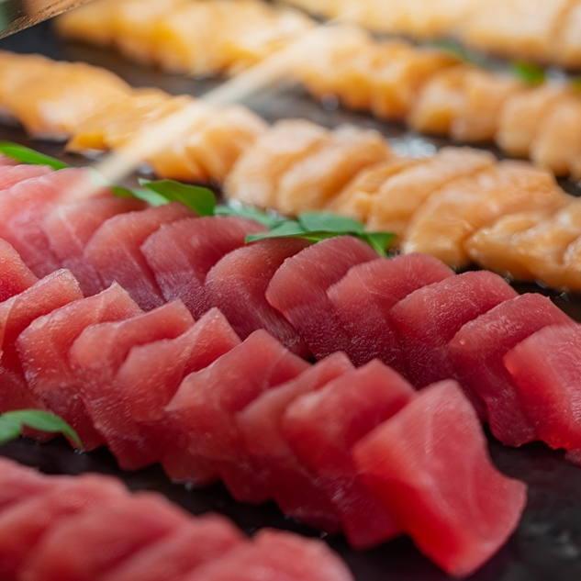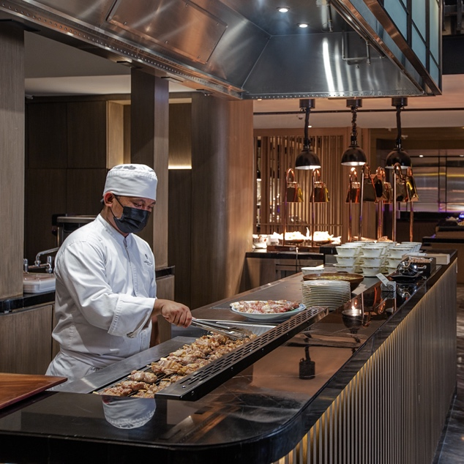
Tuna and salmon sashimi; live station for grilling seafood and skewered meat
*Some menu items may change slightly without prior notice due to ingredient availability and quality

Saturday Lunch and Friday to Sunday Dinner Buffet days will still include a carvery station, seasonal produce and seafood such as shrimps, mussels, and clams. Some menu items may change slightly without prior notice due to ingredient availability and quality.

For the dessert spread, Pastry Chef Vi Serrano presents the yard long concept – emphasizing each dessert’s deconstructed elements to let you appreciate the culinary team’s meticulous attention to detail. When in Japan: Summer showcases Japan’s summer fruits such as compressed melon in fresh orange juice, cinnamon-spiced watermelon, plum sponge cake, plum wedges, and peach coulis. The deconstructed desserts are paired with crunchy almond streusel, sunflower seeds, raisins, orange coral sponge, and whipped white chocolate ganache.

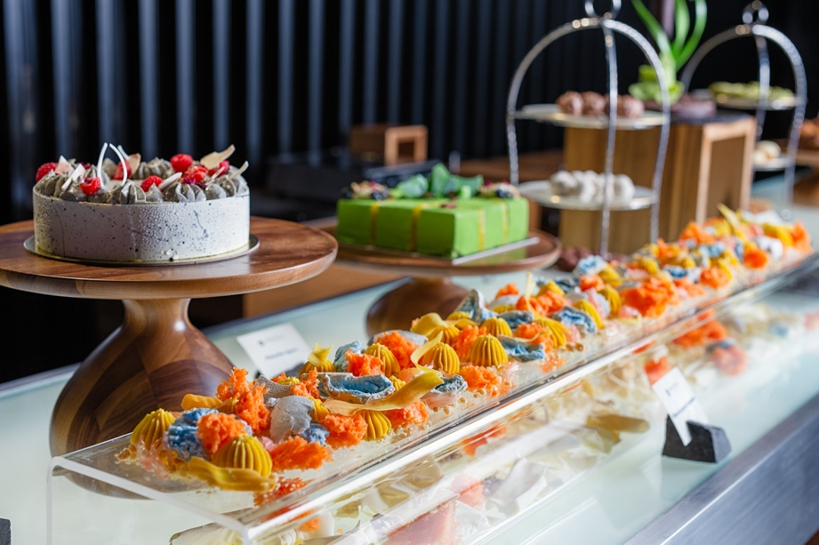
When in Japan: Summer

In addition, you can enjoy Japanese desserts such as dorayaki, wasabi chocolate pudding with strawberry custard sauce, and mochi; chocolates, and assorted cakes including Black Sesame, Irish Profiterole, Pistachio Opera, and Cherry Chocolate.

For Saturday Lunch, the buffet is priced at PHP 2,950 nett per person. Sunday Lunch with free-flow non-alcoholic drinks is PHP 4,300 nett person, while Sunday Lunch with free-flow non-alcoholic and alcoholic drinks is at PHP 5,200 nett per person. Meanwhile, Friday to Sunday Dinner is at PHP 3,150 nett per person.

Guests who would like to include free-flow drinks can avail the beverage upcharge at PHP 650 nett per person for non-alcoholic drinks; PHP 1,700 nett per person for both non-alcoholic and alcoholic drinks. The price is halved for children aged 6 to 12, while kids below 5 years of age can eat for free.

The Kisetsu Weekend Buffet is available at Yawaragi Restaurant, located at the fifth floor atrium hall of Hotel Okura Manila. Advance reservation is highly encouraged. For inquiries and table reservations, call +63 917 842 9067, email yawaragi.service@hotelokuramanila.com, or book online at https://bit.ly/BookATable-Yawaragi.

Follow us for more information at @HotelOkuraMNL on Facebook and Instagram or check our website at www.hotelokuramanila.com

About Hotel Okura Manila and Okura Nikko Hotels
Hotel Okura Manila brings together Japanese omotenashi with Filipino warmth. Okura Nikko Hotels exemplifies the highest in Japanese hotel standards, both in Japan and around the world. Comprising Okura Hotels & Resorts, Nikko Hotels International, and Hotel JAL City, the Group includes 81 hotels in 12 countries and regions.

Hotel Okura Manila is located within Newport World Resorts, Pasay City.

# # #

Contact Information
Ms. Addie Capinding  Director of Sales & Marketing  +63 917 848 1353  addie.capinding@hotelokuramanila.com | Ms. Eunice Cambay Añonuevo  Asst. Marketing & Communications Manager  +63 917 817 5631  eunice.anonuevo@hotelokuramanila.com

