PRESS RELEASE – Festive Season
Celebrate the Holiday Season in Langkawi with Pelangi Beach Resort & Spa
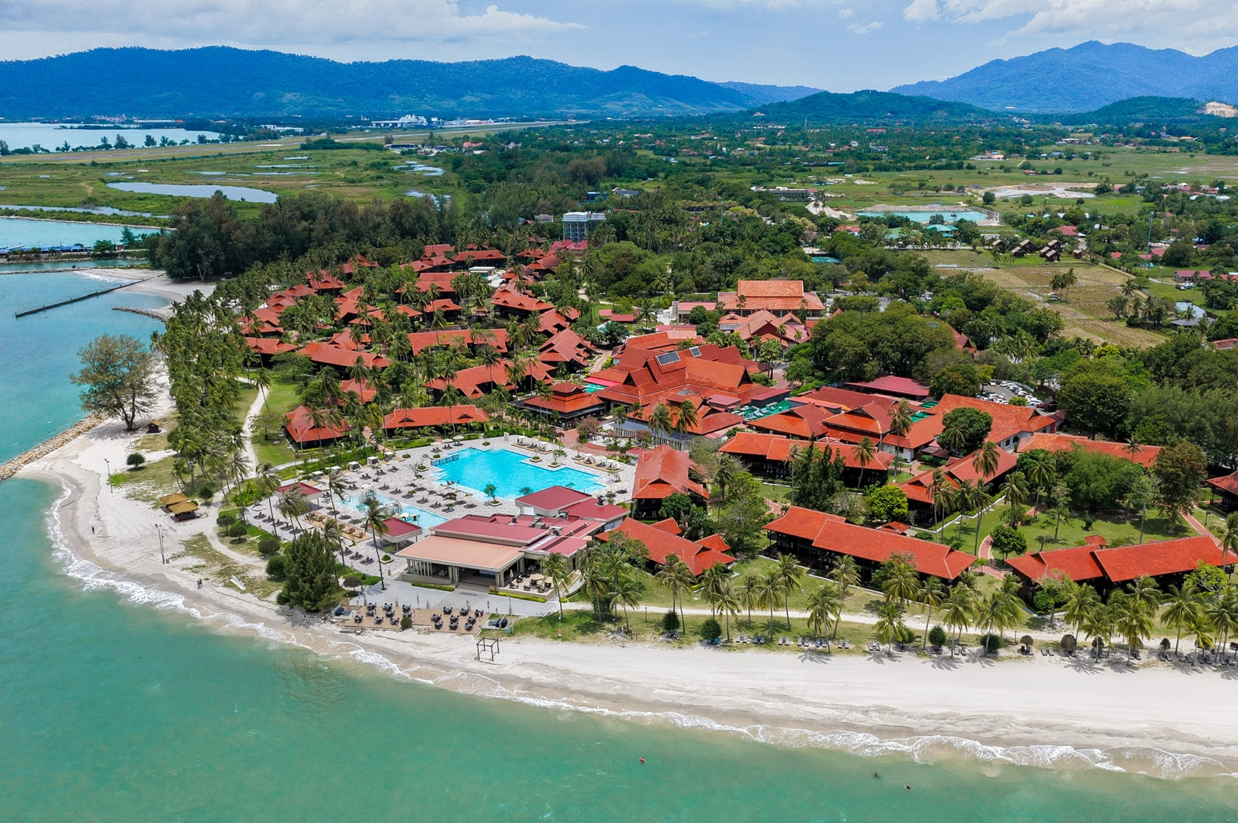
Langkawi, Malaysia – This festive season, immerse yourself in the unparalleled luxury of Pelangi Beach Resort & Spa, Langkawi. Set on an expansive 35-acre estate in Cenang, the resort boasts exclusive access to nearly half of the pristine Cenang Beach, spanning approximately 1 kilometer. With its newly renovated swimming pool and upgraded facilities, Pelangi offers an elevated experience of luxury and comfort. From the sky, travellers arriving in Langkawi can even catch a glimpse of this magnificent resort as their plane descends—its stunning beachfront property is truly hard to miss.
Nestled along Langkawi’s immaculate white sands, Pelangi Beach Resort & Spa invites you to embrace the holiday spirit amidst tropical splendour and refined celebrations. Treat yourself to indulgent Christmas feasts, dazzling New Year's Eve festivities, and exclusive festive packages designed to make your getaway extraordinary. Whether you're enjoying the lush tropical scenery or soaking in the festive ambiance, Pelangi Beach Resort & Spa promises an unforgettable holiday experience.

A Mesmerizing Christmas Celebration in Langkawi


Celebrate Christmas in Langkawi with elegance and festivity, surrounded by the turquoise waters of the Andaman Sea. From lavish dining options to magical family experiences, Pelangi creates an unforgettable ambiance to cherish the season’s warmth and joy.

Christmas Eve Highlights (24 December 2025)
Event | Time | Venue | Details | Price
Christmas Eve Buffet Dinner | 07:00PM – 10:00PM | Pelangi Grill | Begin with complimentary pre-dinner drinks by the beach (6:00 PM), followed by a buffet of Christmas BBQ favourites and contemporary creations. | RM300 nett (Adult)  RM150 nett (Child)  Add-On Free Flow: RM100 nett (Adult) RM50 nett (Child)
Christmas Eve Countdown Party | 09:00PM till late | Pelangi Lounge | Welcome Christmas with live music, festive cocktails, and a 30% discount on all beverages. | Complimentary Entry

Christmas Day Highlights (25 December 2025)
Event | Time | Venue | Details | Price
Magical Morning with Santa | 09:00AM onwards | Entire Resort | Santa spreads happiness throughout the resort, creating joyful moments for children and families. | Complimentary
Christmas Brunch | 12:30PM - 04:00PM | Spice Market | Delight in a spectacular Christmas brunch featuring holiday roasts, mains, and indulgent desserts. | RM120 nett (Adult)  RM60 nett (Child)  Add-On Free Flow: RM100 nett (Adult)
Christmas Roast & BBQ Dinner | 7:00PM - 10:00PM | Pelangi Grill | End Christmas Day with a festive buffet showcasing holiday roasts and modern BBQ creations. | RM220 nett (Adult)  RM110 nett (Child)  Add-On Free Flow: RM100 nett (Adult)

RING IN 2026 WITH LANGKAWI’S MOST GLAMOROUS NEW YEAR’S CELEBRATION

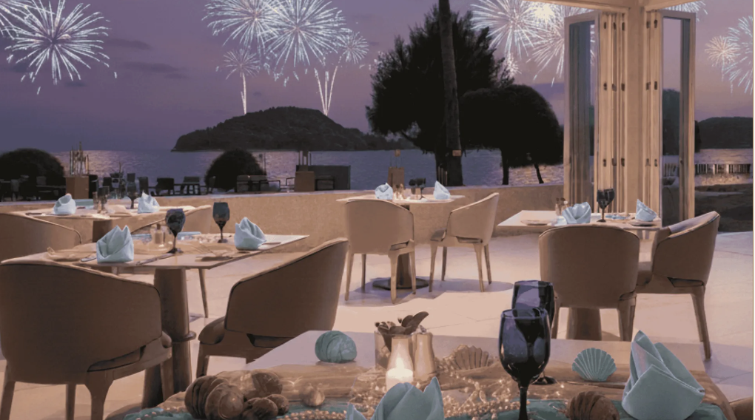
New Year’s Eve in Langkawi is more than just a date on the calendar – it’s a sensory experience filled with breathtaking views, exquisite food, captivating music, and unforgettable moments. On 31 December 2025, Pelangi Beach Resort & Spa promises a dazzling beachfront celebration where the sea meets the sky in dreamy pastel hues.
Guests can expect an enchanting evening under the stars with live entertainment, dazzling fireworks, and a whimsical atmosphere tailored for families and friends. From sparkling décor to intricate ocean-inspired details, every moment has been thoughtfully crafted to deliver an unforgettable experience.
Event | Time | Venue | Details | Price
DJ Poolside Performance | 3:00PM – 5:00PM | Horizon Pool | Soak in Langkawi's tropical vibes while enjoying trendy DJ beats, sunset views, and lively poolside energy. | Complimentary
New Year’s Eve Gala Dinner | 07:00PM – 10:00PM | Choose between three different dining venue | Enjoy a luxurious dining experience in your choice of setting – beachfront, intimate indoors, or vibrant elegance – all with unlimited Premium Beverages &Live Cooking Stations | RM800 nett (Adult)  RM400 nett (Child)
After-Dinner Party & Fireworks | 09:00PM – Midnight | Beachfront | Dance under Langkawi’s star-filled skies, sip curated cocktails, and toast to 2026 with spectacular fireworks by the sea. | Complimentary

Exclusive Room Offer – Celebrate the New Year in Style

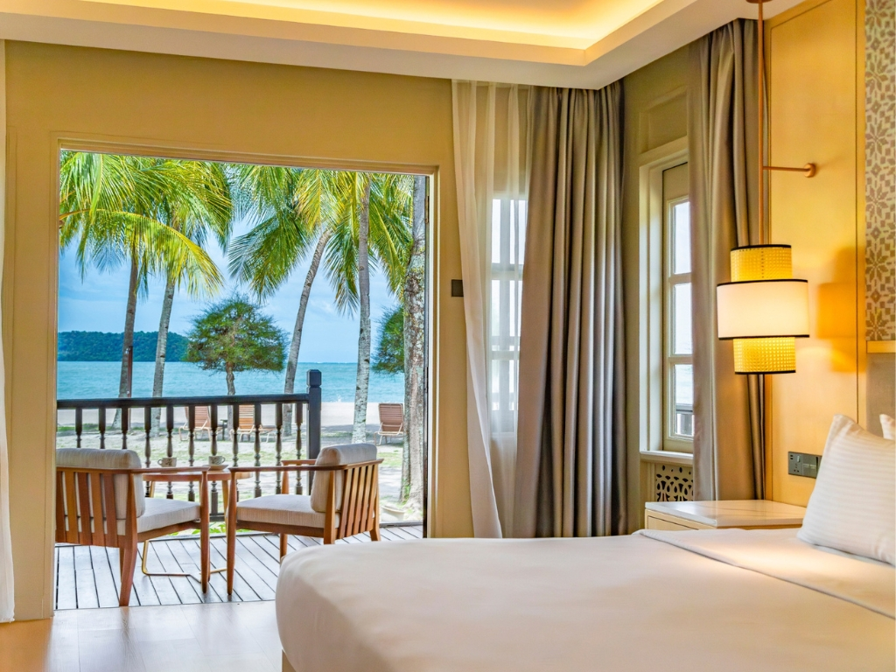

Price: Starting from MYR 3,071.48
(Including taxes and fees per room per night for two adults.)

Special Offer Includes:
- 1-night stay with breakfast for two adults.
- Fantasea New Year’s Eve Gala Dinner for two adults.
- MYR 50 daily resort credit for F&B or Spa.
- Daily ice cream treat at Pelangi Lounge.
- Guaranteed late checkout until 2 PM.
- Complimentary return airport transfer for suite bookings.
- One-time sundowner at Kelapa Bar.
- Birthday treat if you stay on your birthday.

Why Celebrate the Holidays in Langkawi with Pelangi Beach Resort?
Pelangi Beach Resort & Spa is the top luxury destination in Langkawi for festive holidays. Whether you’re planning a romantic escape, a family gathering, or a year-end celebration with friends, Pelangi offers:
- World-Class Dining: Carefully curated menus featuring international and local dishes to satisfy the most refined palates.
- Exclusive Venues: From beachfront elegance to private and cozy spaces, choose the perfect setting for your gatherings.
- Bespoke Accommodations: Stay in luxurious beachfront villas, perfect for families or couples, or opt for suites with panoramic ocean views.
- Signature Holiday Experiences: From Santa’s magical rounds to jaw-dropping fireworks by the beach, every moment at Pelangi is tailored to create lasting memories.
This festive season, create lasting memories at Pelangi Beach Resort & Spa, Langkawi. From world-class dining and unforgettable celebrations to breathtaking beachfront views, Pelangi offers the perfect setting for a truly extraordinary holiday.
For bookings or inquiries, visit www.pelangiresort.com or contact us at enquiries@pelangiresort.com.
Celebrate in style, where luxury and the festive spirit come together at Pelangi Beach Resort & Spa.
-THE END-

FOR INQUIRIES

Address:  Pelangi Beach Resort & Spa Langkawi  Pantai Chenang  07000 Pulau Langkawi  Kedah Darul Aman, Malaysia  Tel: +60 4 952 8888  Email: enquiries@pelangiresort.com  Website: http://www.pelangibeachresort.com/ | PR CONTACT DETAILS:  Director of Sales & Marketing  SAM POH CHOO  Email: pohchoo.sam@pelangiresort.com  Tel: +60 34481 1188  Mobile: +60 12 338 3499

Pelangi Beach Resort & Spa Langkawi
Pelangi Beach Resort & Spa, Langkawi, is a five-star beachfront sanctuary set along the idyllic shores of Pantai Cenang, seamlessly blending traditional Malay heritage with contemporary luxury since 1989. Spanning 35 acres of lush tropical beauty, the resort features 355 elegantly appointed rooms across 51 low-rise chalets, offering five unique panoramic views—Beach, Island, Pool, Lake, and Garden. Renowned for its exceptional hospitality, the resort delivers unforgettable experiences, from indulgent dining across eight distinctive outlets to rejuvenating wellness at its spa and engaging recreational activities for all ages. With state-of-the-art meeting facilities, scenic event spaces, and family-friendly amenities, Pelangi Beach Resort & Spa caters to leisure and business travelers alike, cementing its status as an iconic destination that redefines luxury island living. For more information, visit www.pelangibeachresort.com.
Tradewinds Hotels & Resorts
Tradewinds Hotels & Resorts is a premier hospitality brand offering a diverse portfolio of iconic accommodations across Malaysia, including beach resorts, eco-retreats, golf resorts, and city hotels. Striving to redefine comfort and convenience, each hotel and resort under the Tradewinds umbrella is thoughtfully designed with a blend of aesthetic architecture, personalized guest service, and eco-friendly initiatives. Renowned for crafting memorable experiences, Tradewinds locations include renowned properties such as The Danna Langkawi Resort & Beach Villas, Pelangi Beach Resort & Spa Langkawi, Rebak Island Resort & Marina, Glenmarie Hotel & Golf Resort, Hilton Petaling Jaya, and Hilton Kuching, among others. Committed to sustainability and social responsibility, Tradewinds Hotels & Resorts combines luxury, warmth, and innovation to cater to the needs of discerning travelers, while fostering an inclusive and environmentally conscious community. For more information, visit www.tradewindshotels.com

