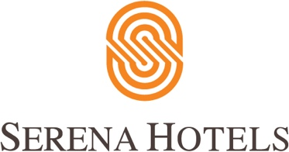

Corporate
10th February, 2022

Serena Hotels sponsors Winter Sports 2023 in collaboration with PAF

GILGIT: The 30th National Ski Championship, 17th Shah Khan Ski Cup and seventh Snowboarding Championship concluded at the PAF Ski Resort, Naltar on Friday.

Ninety-three athletes of 10 teams from the four provinces, AJK and Gilgit-Baltistan participated in the competitions organised by the Pakistan Ski Federation in collaboration with the Pakistan Air Force.

Gilgit-Baltistan Scouts claimed the winners trophy of the National Ski Championship while the Pakistan Air Force bagged the Shah Khan Ski Cup title.

In the Giant Slalom category, Mohammad Zahid of PAF, Abbas Tahir of Gilgit-Baltistan Scouts and PAF’s Obaidullah won gold, silver and bronze medals, respectively. Gold medal for the Snowboarding Championship was won by Khalid Hussain of Gilgit-Baltistan Winter Sports Association, silver was earned by Rehman Wali of PAF while Ali Hasnain of Hindukash won bronze.

Retired Air Commodore Iftikhar Bajwa, member of the Executive Committee of Winter Sports Federation, Pakistan, distributed medals and prizes among the athletes.

Addressing the ceremony, Iftikhar appreciated PAF’s efforts and those of the Winter Sports Federation for promoting winter sports in Pakistan, and said PAF was fully committed to promoting winter sports sports in Pakistan.

