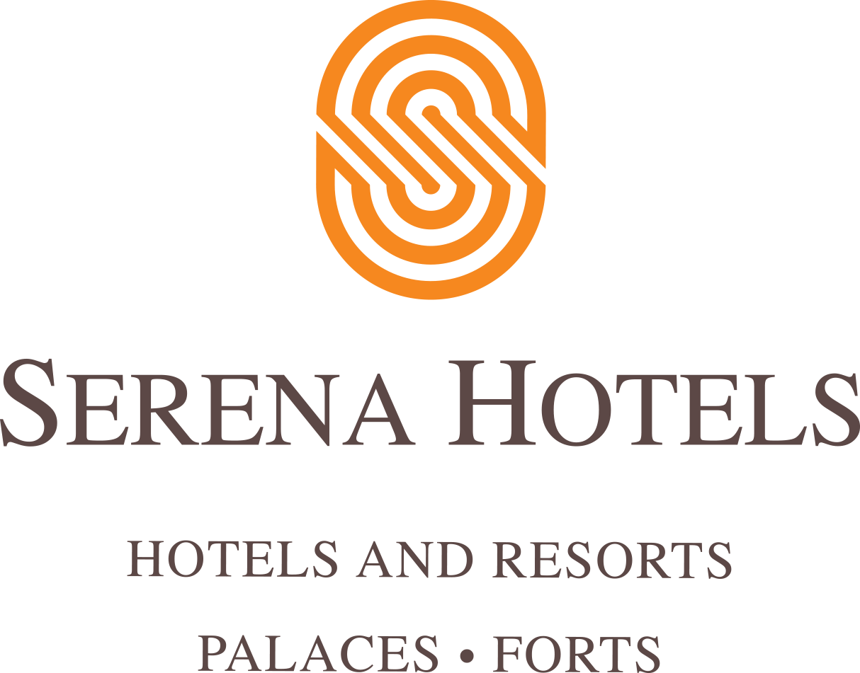
PRESS RELEASE IMMEDIATE RELEASE
Serena Hotels continues flood relief effort, by joining hands with
National Disaster Management Authority
Islamabad, Pakistan, 26th January 2023:
Serena Hotels strongly believes in helping vulnerable communities through its various initiatives under the ambit of its corporate social responsibility; known as Jazba -e-khidmat.
Monsoon 2022 brought an unprecedented onslaught of floods known as Super flood that had a catastrophic impact on millions, submerging the 1/3rd of Pakistan.
The floods affected all four provinces and approximately 15% of its population. At the beginning of 2023, an estimated 5 million people remained exposed to or living close to flooded areas. In the Sindh Province, an estimated 89,000 people remain displaced with limited access to food sources and shelter.
Not all floodwaters have receded, combined with the onset of severe winter cold that brought a new set of problems for the people living in the flood affected areas. Hence, the importance of meeting critical needs while investing in recovery to prevent additional disaster impacts and help people rebuild their lives is imperative and the need of the hour.
Funds were raised with the help of the guests and associates along with different diplomatic missions, where fundraising galas were hosted with the Czech, Turkish, Italian, and Thai Embassies. Serena Hotels matched the amount raised with their monetary contribution to double the donated funds.
With instrumental efforts of Quetta, Swat and Peshawar Serena Hotels, and the regional team; ration bags and tents were dispersed to the affectees of the said cities and their adjoining areas.
Serena Hotels collected a substantial amount which was handed over to the National Disaster Management Authority for aid to the affectees in a ceremony held on 26th of January, so that they could be utilised for rehabilitation of the affectees.

