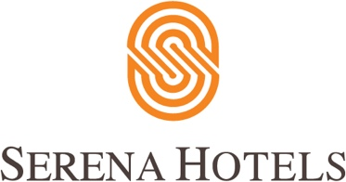

Corporate
22nd May, 2022
Islamabad

The Pakistan Foreign Office Women’s Association (PFOWA) and Serena Hotels hosted a Fashion Show – Connecting Through Colours

ISLAMABAD: The Pakistan Foreign Office Women’s Association (PFOWA) and Serena Hotels jointly hosted a Fashion Show - Connecting Through Colours at the Islamabad Serena Hotel in collaboration with Pakistan Television and Half Apple Events.

The event was a multicultural get together with people from all backgrounds witnessing a spectacular fashion show. Attended by diplomats and their spouses, government dignitaries, corporate executives etc, the fashion show served to appreciate the different cultures, colours, and customs of the different regions and nations.

The event started off with a welcome note and brief introduction of the Cultural Diplomacy initiative of Serena Hotels by Mr. Aziz Boolani CEO, of Serena Hotels South & Central Asia. He mentioned that Serena Hotels is an extension of the Ministry of Foreign Affairs as Serena Hotels also project the image of the country through its hospitality, culture, interiors and impeccable services and brings all segments of the society on a single platform through various Diplomacy Initiatives but not limited to Cultural Diplomacy, Sports Diplomacy, Adventure Diplomacy, and Public Diplomacy initiatives.

He praised PFOWA for their unwavering support and active participation in a number of community initiatives including health, education, and skill development. He assured the management of PFOWA, Serena Hotel’s continuous support in their CSR activities as it goes well with Serena Hotel's mission also to serve the community.

The Foreign Secretary, Mr. Sohail Mahmood appreciated the collaboration efforts of PFOWA & Serena Hotels over the years. PFOWA, being a non-political social and charitable organisation, works to promote a better understanding of the social, cultural, and economical life of Pakistan. It regularly organises programs including exhibitions, cultural shows, art & craft bazaar and other social events.

The members and heads of various Diplomatic Missions participated in the catwalk while displaying their own cultural dresses. These Diplomats also walked on the ramp portraying Pakistani’s regional outfits. A colourful wedding ramp walk depicting different Wedding outfits worn on Mehndi, Baraat and Walima occasions in Pakistan were the key highlights of the show.

