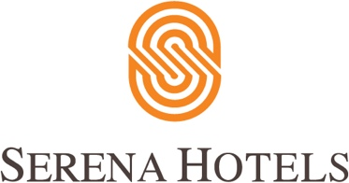

15th July 2021
Serena Corporate

Serena Hotels to train NUST’s female graduates

The Serena Hotels on Wednesday signed a memorandum of agreement (MoA) with the National University of Science and Technology to induct the female graduates from the NUST Business School (NBS) into its management trainee programme.

CEO of the Serena Hotels South and Central Asia Aziz Boolani and NUST rector Engineer Javed Mahmood Bukhari attended the MoA signing ceremony along with the pro-rectors and NBS dean. The representatives of the business and hospitality sectors were also in attendance.

According to the MoA, the initiative is meant to bring together the expertise of the country's leading business school at NUST and Serena Hotels, a leading hospitality brand, to offer women graduates of NBS a valuable training opportunity for hands-on experiential learning and training in the field of hospitality management in a structured and professional setting.

The one-year programme will provide management trainees with immersive learning to equip them with a holistic view of the business, as well as understanding the inter-relationships between different functional departments. The training is envisaged as an accelerated pathway that will help unlock their advancement to higher-level management positions in the industry.

Aziz Boolani said the number of female professionals in the hospitality sector is traditionally low.

He said as a leading hotel chain, Serena Hotels made every effort to encourage women in their professional development for assuming higher positions, including the leadership role.

