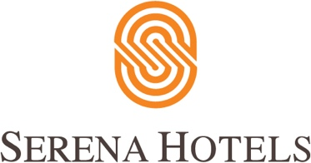

Corporate
1st July, 2022
Islamabad

Serena Hotels organizes a Mango Festival with MoFA

ISLAMABAD: Serena Hotels organised a Mango Festival in partnership with the Ministry of Foreign Office as a part of Pakistan’s 75-year anniversary celebrations

This was part of the series of activities and events being organized throughout the year to commemorate 75 years of Pakistan’s Independence – Pakistan’s Diamond jubilee.

Under the theme of #75thPayKuchKhaas, the event focused on projecting Pakistan’s culinary and agrarian richness linked to the production of more than 200 varieties of mangoes – the “king of fruits” that are exported all over the world.

Foreign Minister Bilawal Bhutto Zardari graced the event as the Guest of Honour.

In his remarks, the Foreign Minister highlighted the significance of the festival as part of the events celebrating the 75th anniversary of Pakistan’s Independence.

The festival was held under Serena Hotels' #CulturalDiplomacy initiative which aims to highlight the vast variety and richness of Pakistani culture – including mangoes.

The event was attended by members of the Diplomatic Corps, Business Executives, Bureau Chiefs of Local and Foreign Publications. Embassies of China and UAE also set up stalls offering mango-based dishes from their own cuisine.

The guests were served different varieties of freshly cut mangoes, salads, milkshakes, lassi, chutneys, pickles, desserts, ice cream, and other savoury items that incorporated mangoes.

Guests appreciated the different mango varieties on display as well as the mango-based cuisine offered. This event showcased the potential of Pakistani mangoes as a popular fruit not only in Pakistan but in the international market as well.

