**Heron Island Resort Room Types**

**Reef Rooms:**

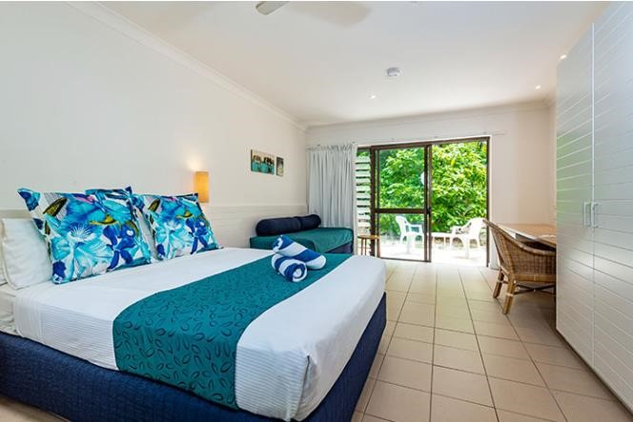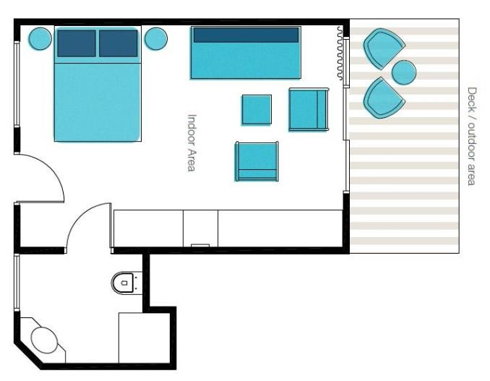

Reef Rooms are located on beautiful North Beach. They have modern décor and sleep a maximum of 3 people. The Reef Room interiors are light and comfortable, featuring modern streamlined bathrooms that match the lines of the living room.

The stunning living areas face onto the water. All Reef Rooms include an en-suite bathroom with shower. The Reef Rooms also boast a day bed that is lit by down lights to make them ideal reading and relaxing spots, while they can be transformed into a bed at night. Disabled access is also available.

Amenities in Room: Room Size:

Queen Size Bed 5.6m x 3.9m

Day Bed (Single Bed) 21.85 sqm

Bar Fridge

Tea and coffee making facilities

Outdoor seating

Toilet

Shower

Vanity

Desk and chair

Wardrobe