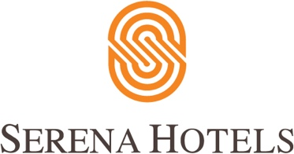

Corporate
1st July, 2022
Islamabad

Expansion of Serena Hotels in Peshawar to promote tourism in Pakistan

ISLAMABAD: Tourism Promotion Services (Pak) Limited has entered into a Business Sale Agreement with Pakistan Services Limited to acquire Pearl-Continental Hotel Peshawar, with the intent to promote the untapped potential for tourism in Khyber Pakhtunkhwa province. It will be Serena Hotels’ second property in KP province after the Swat Serena Hotel, increasing the total number of Serena Hotels in Pakistan to 9.

The addition of Serena Hotel in Peshawar, the oldest city of Pakistan with a rich cultural heritage, will not only help in extending the tourist circuit in KP province but will also allow regional connectivity for tourists and business travelers through its portfolio of hotels in Islamabad, Peshawar, Kabul and Dushanbe. The Serena Hotels has plans to further expand its portfolio to other Central Asian countries in the future.

Serena Hotels in Pakistan is playing a pivotal role in promoting tourism in underdeveloped areas of Pakistan with four properties in Gilgit-Baltistan including three Heritage properties. Two new Serena Hotels are under construction in Hunza and Sost in Gilgit-Baltistan. The properties will showcase the scenic areas, rich cultural heritage, local cuisine, and traditional hospitality of the region, while providing economic opportunities for the local community through skill development, employment, and enhancement of the value chain. As destination hotels, they will not only allow tourists to relax and enjoy the stunning views, but will also provide venues for corporate retreats, family reunions, weddings, and conferences.

The Company plans to invest in Peshawar Hotel for upgrading the guest rooms, restaurants, banquet hall, meeting rooms, health club, public areas, and service delivery in line with Serena Hotel’s standards.

