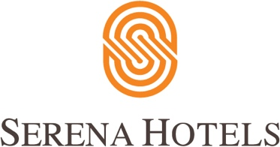

10th October 2021
Serena Corporate

CAS-Serena Hotels International Squash Tournament

Pakistan Squash Federation (PSF) in collaboration with Pakistan Air Force, Serena Hotels, and Combaxx Sports, organized Chief of the Air Staff-Serena Hotels & Combaxx Sports International Squash Championships for Men & Women at Mushaf Squash Complex, Islamabad between 11 – 15 October 2021.

Apart from Pakistan, a group of 22 foreign players from 10-countries (Austria, Czech Republic, Egypt, England, France, Hong Kong, Russia, Serbia, Spain & Switzerland) entered in Men & Women events.

The Finals of Men & Women events were played on 15 October 2021. Air Chief Marshal Zaheer Ahmed Baber Sidhu, Chief of the Air Staff, Pakistan Air Force who is also the President of Pakistan Squash Federation, graced the closing ceremony as Chief Guest and awarded trophies and prizes money to the finalists.
The Women Final was played between World No 69 Marie Stephan from France and World No 81 Salma Eltayeb from Egypt wherein Salma Eltayeb defeated Marie Stephan with a game score of 11-6,12-10,11-04 in 18 minutes. Whereas the Men Final was played between World No 59 Auguste Dussourd from France and World No 67 Moustafa El Sirty from Egypt in which Moustafa El Sirty defeated Auguste Dussourd with a game score of 09-11, 11-07, 11-06, 12-10 in 47 minutes and won the championship finals.

The successful hosting of the mega event signifies that Pakistan is a sports-loving and perfectly peaceful country to host international sports events.

