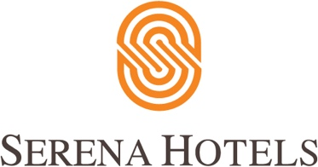

Corporate
11th November 2022

Serena Hotels hosts a two day crafts festival with Behbud Crafts Association

ISLAMABAD: Serena Hotels is sponsoring a two-day crafts extravaganza with Behbud Crafts Association called “Embroidering Dreams”, which has kicked off on Friday with an inaugural event ribbon cutting ceremony launched by the Honorable Begum Samina Alvi.

First Lady, Begum Samina Alvi graced the opening event which was also attended by notable members from the diplomatic missions, dignitaries, and people from the corporate and business sectors.

Embroidering Dreams showcases and highlights the talented women of Pakistan, through their exceptional threadwork, and other handmade crafts and organic products.

This two-day exhibition is an ode to the skillset of these hardworking artisans whose skill with traditional needle works is enabling them to earn through their own capabilities and represents the traditional craftwork of different regions of Pakistan, forming a kaleidoscope of colours, exquisitely crafted thread work from across Pakistan.

Mr. Aziz Boolani, CEO Serena Hotels discussed how Serena Hotels as an organisation actively projects and promotes traditional crafts as part of its overall vocational skill enhancement agenda of supporting and empower the rural women by enhancing their economic prospects. Mr. Boolani said Pakistan was blessed with so much talent in traditional crafts and it was a privilege for Serena to play a role in showcasing them.

Ms. Abida Malik talked about the intention behind Behbud, an organisation run entirely by women volunteers and has over the years evolved into Pakistan’s premier brand for ethnic and sustainable fashion. Behbud, inaugurated in 1972, is a non-profit that focuses on empowering women through their skillset, aids marginalized women by providing them with free of cost vocational training in local embroideries, free healthcare, counseling, and education for their children.

The two-day event was a visual delight for the attendees, where the local artisans got global exposure as Serena Hotels has an international and national customer base.

