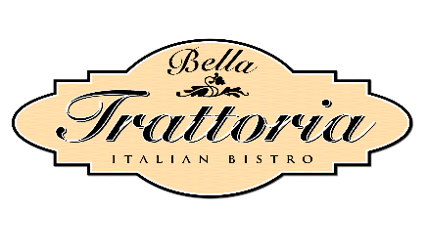

ANTIPASTI e INSALATE
Focaccia Garlic Bread garlic butter, parsley, olive oil $14
Bruschetta al Pomodoro fresh diced tomatoes, garlic basil, olive oil, crostini $13
Calamari Fritti fried calamari, chili flakes, garlic aioli $18
House Made Meatballs ground beef, parmesan, herbs, tomato sauce $15
Caprese Salad heirloom tomatoes, mozzarella ovaline, extra virgin olive oil, basil $17
Burrata Salad baby arugula, burrata, baby beets, balsamic reduction $15
House Salad romaine hearts, radicchio, pancetta, parmesan, house balsamic vinaigrette $15

PIZZA
Margherita ovaline mozzarella, marinara, fresh basil $17
BBQ Chicken bbq sauce, smoked gouda, red onions, micro cilantro $17
Meat Lovers ground beef, ham, Italian sausage, pepperoni, marinara $19
Three Cheese marinara, mozzarella, provolone, ricotta $16
Pepperoni marinara, mozzarella, parmesan, pepperoni $18
Vegetarian mixed vegetables, pesto, mozzarella $14

PASTA & HOUSE CLASSICS
Innkeepers Spicy Penne spicy sausage, oregano, chili flakes, tomato cream sauce $27
Spaghetti Meatballs all beef meatballs, tomato sauce, herbs $27
Short Ribs Tortellini lemon garlic cream sauce, parmesan cheese $31
Rigatoni Bolognese beef ragu, marinara $28
Chicken Parmesan linguine, mozzarella, marinara sauce $27
Trancio di Salmone Atlantic salmon, piccata sauce, risotto $31
Eggplant Parmigiana baked eggplant, ricotta, parmesan, marinara, $24
Lasagna a la Bella Trattoria beef and Italian sausage, marinara, ricotta, spinach, $29

PANINI sandwiches-served 11am-4pm
Meatball Mozzarella mozzarella, ground beef, marinara, parmesan cheese $16
Italiano arugula, red onions, tomato, finocchio, pepperoni, mozzarella ovaline $17
Caprese tomato, ovaline cheese, wild arugula, balsamic $14
Chicken Parmesan breaded chicken breast, tomato sauce, wild arugula $19

DOLCI
Tiramisu lady fingers, brandy, Callebaut chocolate, cocoa powder, touch of grand Marnier $12
Bella Trattoria’s Panna Cotta hazel nut sponge cake, vanilla custard, grand Marnier $8
Cannoli sweet ricotta, dark chocolate, pistachio, cinnamon, powder sugar $9
Gelato pistachio, dark chocolate, salted caramel, vanilla bean, $7

Duane and Kelly Roberts “Keepers of the Inn”
20% Gratuity for Gatherings of 6+
*Consuming raw or uncooked meat, poultry, seafood, shellfish, or eggs may increase your risk of food borne illness, Especially
if you have certain medical conditions. Please inform your server if you have any food allergies.

