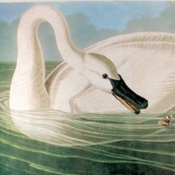

397 Hopmeadow Street | P.O. Box 579 | Simsbury, Connecticut 06070 | 860.651.5700

The Simsbury Inn, one of a kind...
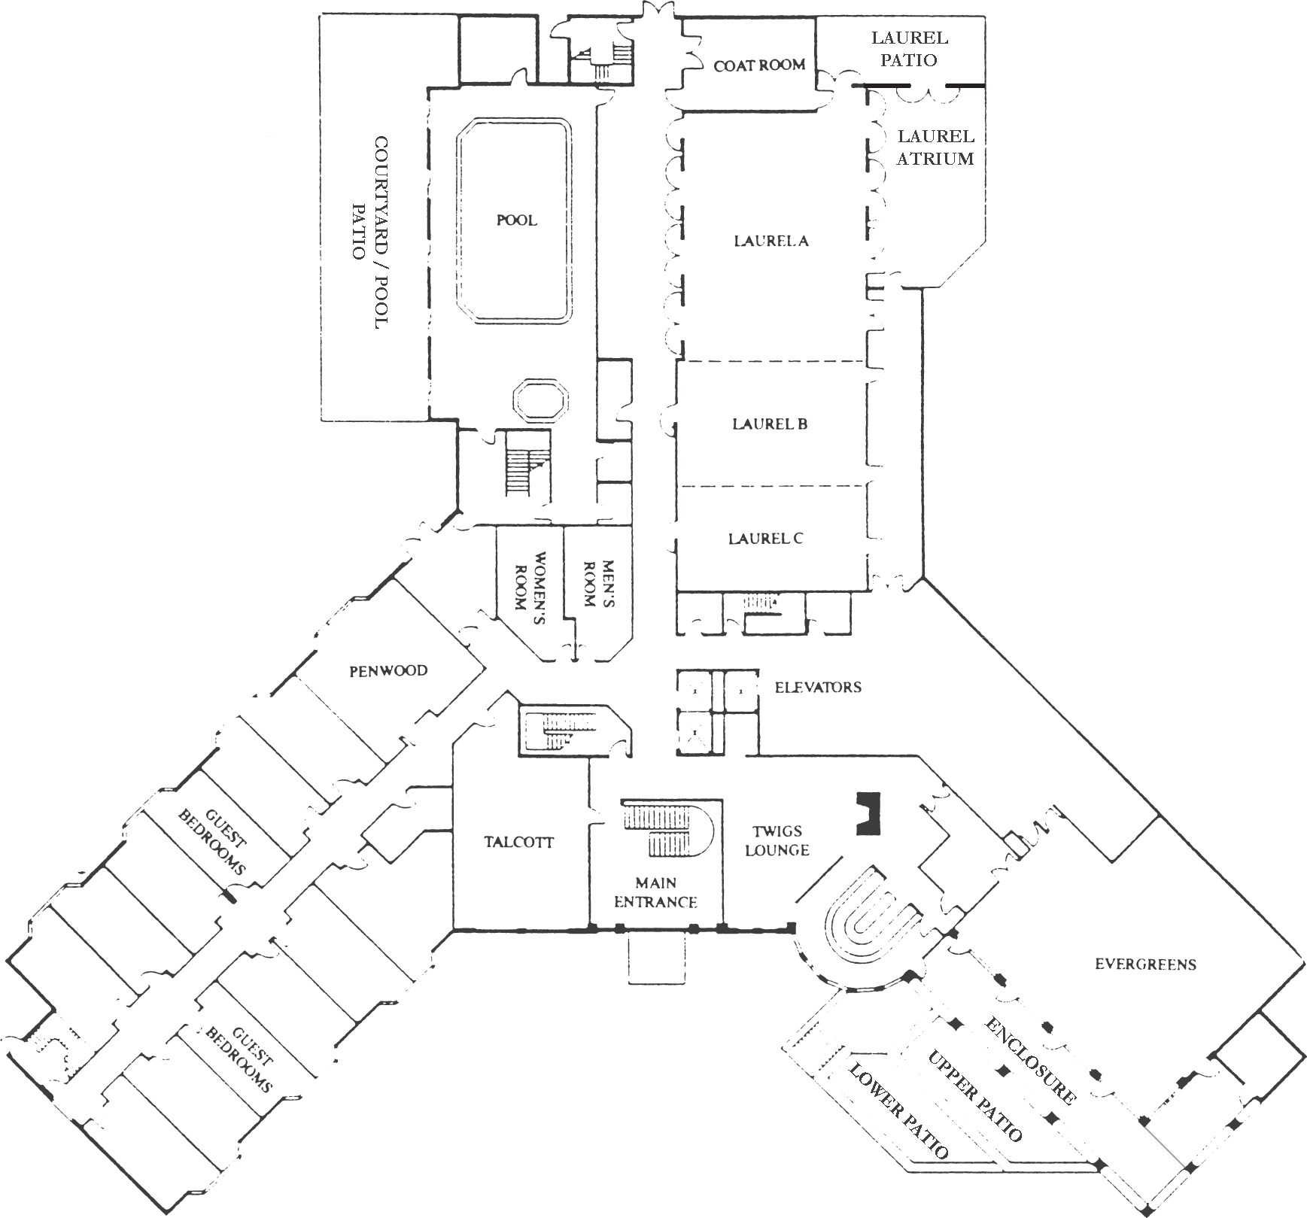
Overlooking the treetops of the beautiful Farmington Valley, The Simsbury Inn has a unique character, the building décor and setting surround its guests with the warmth and charm of a New England country inn. Yet, when it comes to hosting a special event, The Simsbury Inn offers the services and accommodations typical of a luxurious hotel:

- Banquet & meeting facilities accommodating 30 to 300 persons
- 98 beautifully appointed guest rooms
- Twigs Lounge offering cocktails and a pub menu with a beautiful
mountain view
- Indoor Pool & Jacuzzi
- Exercise room & Sauna
- Tennis courts, basketball hoop, ping pong table, free bikes & yard games (seasonal)
- Wood fired cowboy cauldron and gas fire pit
- Free Parking

The Simsbury Inn is just a short drive from two interstate highways and only 20 minutes from Bradley International Airport. Your guests will take advantage of our accessible
and convenient location.

Ideal for a variety of functions
Whether you’re meeting with friends and family, The Simsbury Inn is the ideal choice for any occasion. Our expert staff will be your guide from planning to conclusion to make your event extraordinary. Book your next event with us:

- Corporate Meetings
- Conferences
- Retreats
- Weddings
- Bar/Bat Mitzvahs
- Anniversary Celebrations
- Retirement Parties
- Reunions
- Baby & Bridal Showers

Treat your guests to a memorable event surrounded by luxury.
Call The Simsbury Inn to begin planning your special event.

Meeting & Banquet RooM DiMensions

 | Size | Square Footage | Ceiling Height | Banquet | Banquet Dance | Reception | School Room | U-  Shape | Theatre Style | Conference | Hollow Square | Ovals/ Meeting
Laurel Ballroom | 89’x35’ | 3115 | 11 1/2’ | 240 | 200 | 270 | 156 | 70 | 300 | n/a | 75 | 180
Laurel A/B | 71’x35’ | 2485 | 11 1/2’ | 160 | 100 | 230 | 120 | 60 | 200 | n/a | 65 | 130
Laurel A | 48’X35’ | 1680 | 11 1/2’ | 100 | n/a | 180 | 110 | 41 | 150 | n/a | 46 | 88
Laurel B/C | 41’x35’ | 1435 | 11 1/2’ | 100 | 60 | 90 | 80 | 36 | 180 | n/a | 41 | 64
Laurel B | 23’X35’ | 805 | 11 1/2’ | 60 | n/a | 50 | 45 | 29 | 70 | 28 | 36 | 40
Laurel C | 18’X35’ | 630 | 11 1/2’ | 40 | n/a | 40 | 30 | 26 | 60 | 28 | 30 | 32
Laurel Atrium | 37’x18’ | 684 | 8 1/2’ | 40 | n/a | 40 | 30 | 30 | 50 | 28 | 30 | 40
Evergreens | 50’x42’ | 1973 | 11 1/2’ | 95 | 80 | 130 | 40 | 30 | 70 | 25 | 25 | n/a
Evergreens Enclosure | 63’x11’ | 693 | 11’ | 30 | n/a | 40 | n/a | n/a | n/a | n/a | n/a | 30
Talcott | 25’X22’ | 550 | 9’2” | 50 | n/a | 30 | 21 | 20 | 50 | 22 | 28 | 36
Penwood | 18’X26’ | 468 | 9’2” | 30 | n/a | 25 | 20 | 18 | 30 | 22 | 24 | 18

