The Award ceremony for Highest Altitude Marathon concludes at Serena

23rd September 2019: An award ceremony was held for the Serena Hotels sponsored Highest Altitude Road Marathon Khunjerab Pakistan 2019. The chief guest on the occasion was Air Chief Marshal Mujahid Anwar Khan HI (M).
A total of 154 athletes, including 39 international runners from 17 countries, participated in the race, which was held in three categories, ultra marathon (50km), marathon (42km) and half-marathon (21km). A brief video compilation of the key moments of the high-altitude marathon was shown to the audience, and athletes shared with the audience the key moments and memorable anecdotes from the marathon.
It was a momentous occasion in the history of Pakistan as 154 ecstatic long distance runners from across the world enthusiastically ran on the descending Karakoram Highway, starting from the magnificent Khunjerab Top and ending at Sost, a small town in the majestic pass.
Serena Hotels sponsored the event as part of its Adventure Diplomacy initiative that encourages human engagement with nature in ways that test physical prowess, endurance and commitment.
Air Chief Marshal Mujahid Anwar Khan HI (M) said, “It gives me great pleasure to be among world-renowned athletes from all over the globe. I convey my gratitude to the international athletes who have participated in this event which took place in one of the most beautiful landscapes anywhere in the world. I hope you have enjoyed the picturesque northern areas of Pakistan and have enjoyed the warm hospitality of our people”. He also applauded Serena Hotel’s efforts and continued support to Pakistan Air Force in different sports events such as ski, squash and marathons and ensured Serena and PAF partnership in future as well for such healthy sports activities.
The Air Chief presented medals and trophies to the first, second and third place male and female winners for all categories. In 50 km race, Mohammad Siyar from Pak Army clinched the first position, whereas Aslam Khan from GB Scouts remained the runner-up. The third position was clinched by Mohammad Iqbal.
In the 42 km race, army’s athletics team dominated, bagging the first three coveted positions. Umair Haider secured first position and Mohammad Faheem and Sohail Tanveer clinched the second and third spots, respectively.
In 21 km race, Mirza Aslam Baig remained the first, Abdul Muheet and Musawwar ur Rehman won the second and third positions, respectively.

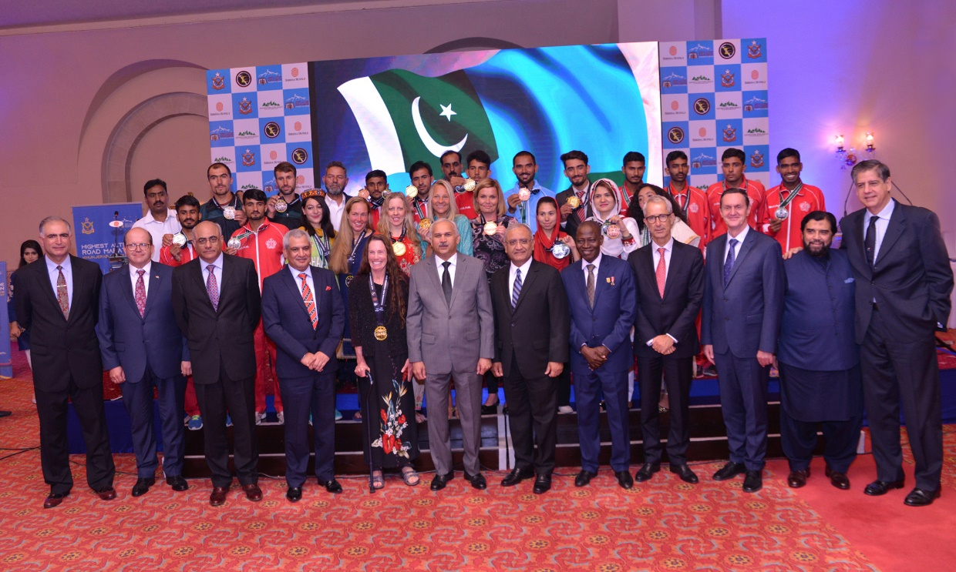

Press Contact
Hussain Odhwani
Manager Marketing & Communication
Tel: +92 333 6349264
hussain.odhwani@serena.com.pk

