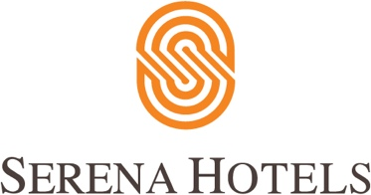

11th September 2021
Serena Corporate

Raabta by Serena celebrates female role models

ISLAMABAD - Serena Hotels, under its Public Diplomacy initiative Raabta, hosted an engaging panel discussion on the topic “Celebrating Female Role Models of Pakistan”at Islamabad Serena Hotel on Friday evening.

The aim of the event was to honor women who have displayed exemplary talent, grit, commitment and professional excellence in their respective fields to make their mark and become role models for the younger generation of women.

The diverse panel included Abida Malik, President of Behbud Association; Kashmala Tariq, Federal Ombudsperson for Protection against Harassment of Women at Workplaces; Alia Zafar, Group Head, People and Organizational Excellence at Bank of Punjab; Sarwat Majeed, the first female General Manager of Serena Hotels Asia; Dr. Muneeza Rizwan, Head of Dermatology at PAF Hospital and young female powerhouse singer Hadia Hashmi, who made her mark with her Nescafe Basement debut.

The panel held an interactive discussion titled “What it means to be an empowered woman in Pakistan” and shed light on factors impacting the professional and personal life of women, and the goals of women empowerment in the Pakistani context, as well as the role of change-makers, corporations and society at large in this quest.

The event was held as part of Raabta, a Public Diplomacy Initiative of Serena Hotels that aims to curate conversations with experts, policymakers and the interested citizenry in order to create knowledge, and develop a wider appreciation of socio-economic subjects relevant to our society. The discussion was moderated by Ms. Sidra Iqbal, a prominent broadcast journalist and curator of Raabta.

The audience included participants from the government, corporate and diplomatic sectorsand civil society who also interacted with the panelists during the Q&A session.

