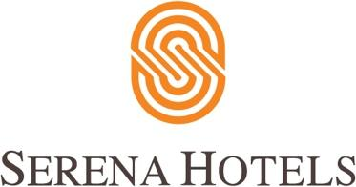

Corporate
Islamabad, February 12, 2020

Prize distribution ceremony for two international Ski events held at Serena Hotels

Prize distribution ceremony of 4th CAS Karakoram International Alpine Ski Cup, 3rd Malam Jabba International Alpine Ski Cup and 27th National Ski Championship was held at Serena Hotel Islamabad.

President of Pakistan Dr Arif Alvi was the chief guest at the occasion. Air Marshal Ahmer Shehzad, Vice Chief of the Air Staff, who is also President Winter Sports Federation of Pakistan, was also present. Aziz Bolani, CEO Serena Hotels, ambassadors, high ranking defence & civil officials also attended the ceremony.

The President thanked the international players for their participation in these events and hoped that they would take along cherished memories of Pakistan’s magnificent beauty and traditional hospitality.

He urged the foreign players to act as the ambassadors of Pakistan and portray the true picture of this land of wonders in their respective countries. He lauded the efforts of Pakistan Air Force and Winter Sports Federation of Pakistan in the promotion of winter sports in the country and added that it would not only help in finding new talent but also promote tourism industry in the country.

The chief guest awarded souvenirs to the winning players. Total 36 International Skiers along with Pakistani skiers participated in both men and women categories of these events.

ABOUT SERENA HOTELS
Serena Hotels has established itself as one of the world’s leading hospitality brands offering quality accommodation, unique holiday and conference solutions, cultural heritage and adventure tourism. Its collection of 35 unique hotels, resorts, safari lodges and camps, palaces and forts located in East Africa (Kenya, Tanzania, Zanzibar, Rwanda and Uganda), Mozambique and South Asia (Pakistan, Afghanistan and Tajikistan) are in some of the world’s most interesting, enchanting, historic and exotic settings.

Press Contact
Hussain Odhwani
Senior Manager Marketing & Communication
Tel: +92 333 6349264
hussain.odhwani@serena.com.pk

