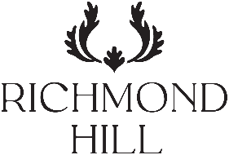

144 Buffet Lunch - Sample Menu
Our team produces a colourful array of dishes bursting with flavours and health benefits to include:
Cured meats, award winning smoked fish and continental cuts, Garden salad bar and healthy composed mix.
Responsibly sourced meat, fish and vegetarian mains with balanced accompaniments.
Assorted fine desserts, seasonal fruits, and west country cheese board.


Starters
Growing leaves, heritage tomatoes, radish, sherry dressing
Thai beef salad with ginger dressing
Spinach, apple and pecan salad, maple dressing
Black kale Caesar salad, rosemary croutons
Tabbouleh and pomegranate, lime dressing
Serrano ham, spicy chorizo, air dried ham,
Smoked salmon, prawn cocktail


Hot Mains
Lemon & thyme chicken breast, cherry tomato concassed
Chestnut mushroom stroganoff
Chervil pilaf rice
Herb crusted cod loin, oyster hollandaise
Panache of seasonal vegetables

Cheese and sweets
Golden cross, Brie de Meaux, West country cheddar crisps bread, house chutney
Mini chocolate Dacquoise
Summer fruit trifle
Framboisier with wild berry compote

* Supplements apply for these items and will be quoted at time of booking as prices may fluctuate seasonally from suppliers.

