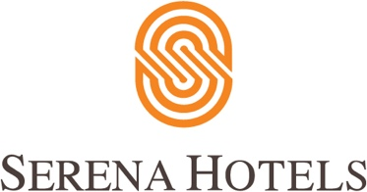

Corporate
14th February, 2022
Islamabad

Serena Hotels and Ecole hôtelière de Lausanne bring Swiss hospitality executive education to Pakistan

ISLAMABAD: Serena Hotels has entered into mandate agreement with École hôtelière de Lausanne – EHL, the world’s best hotel management/hospitality business school in Switzerland, founded in 1893. With consistently high performance, EHL is ranked the best hotel management school by QS World University Rankings for 3 years in a row.

This partnership was announced at the inaugural ceremony of the hospitality management second module attended by the participants and the senior management of Serena Hotels – hosted at the Islamabad Serena Hotel.

The Proficiency Hospitality Management Certificate Program consist of 7 modules that aim to build and explore the capacity of local talent in the hospitality management field while keeping in view the country’s growth potential in tourism and service industry, syncs well in line with government objective with the focus on hospitality management.

The programme has been well received by key institution stakeholder in hospitality, banks, hospital and education sector. It aims to enhance the capacity-building of senior to mid-level executives of Pakistan’s tourism and services sector.

The first module was focused on People Management and the second module is on E-Tourism and Customer Care. The certificate program is expected to complete by end of 2022.
Jochen De Peuter, Consultant at EHL, expressed his gratitude to the Serena Hotels’ management for holding the face to face on premises training sessions.

Mr. Aziz Boolani CEO Serena Hotels encouraged the participants to take the full advantage of the certificate programme as Pakistan is the destination of opportunities, that can only be achieved with the capacity building at the middle and senior level. Serena Hotels Pakistan collaboration with EHL is the right step to develop talents at the middle and senior levels.

